**DIGITAL NURTURE 4.0 DEEP SKILLING JAVA FSE-WEEK1**

**NAME: SIVITHA GUNASEKARAN**

**SUPERSET ID: 6413354**

**WEEK 1: DESIGN PATTERNS AND PRINCIPLES**

**Exercise 10: Implementing the MVC Pattern**

**Scenario:**

You are developing a simple web application for managing student records using the MVC pattern.

**Steps:**

1. **Create a New Java Project:**
   * Create a new Java project named **MVCPatternExample**.
2. **Define Model Class:**
   * Create a class **Student** with attributes like **name, id, and grade**.
3. **Define View Class:**
   * Create a class **StudentView** with a method **displayStudentDetails()**.
4. **Define Controller Class:**
   * Create a class **StudentController** that handles the communication between the model and the view.
5. **Test the MVC Implementation:**
   * Create a main class to demonstrate creating a **Student**, updating its details using **StudentController**, and displaying them using **StudentView**.

**CODE SAMPLES:**

class Student {

private String name;

private int id;

private String grade;

public Student(String name, int id, String grade) {

this.name = name;

this.id = id;

this.grade = grade;

}

public String getName() { return name; }

public int getId() { return id; }

public String getGrade() { return grade; }

public void setName(String name) { this.name = name; }

public void setGrade(String grade) { this.grade = grade; }

}

class StudentView {

public void displayStudentDetails(String name, int id, String grade) {

System.out.println("Student: " + name + " | ID: " + id + " | Grade: " + grade);

}

}

class StudentController {

private Student model;

private StudentView view;

public StudentController(Student model, StudentView view) {

this.model = model;

this.view = view;

}

public void setStudentName(String name) { model.setName(name); }

public void setStudentGrade(String grade) { model.setGrade(grade); }

public void updateView() {

view.displayStudentDetails(model.getName(), model.getId(), model.getGrade());

}

}

public class MVCPatternExample {

public static void main(String[] args) {

Student model = new Student("Ravi", 101, "A");

StudentView view = new StudentView();

StudentController controller = new StudentController(model, view);

controller.updateView();

controller.setStudentGrade("A+");

controller.updateView();

}

}

**MY SCREENSHOT PROOF:**

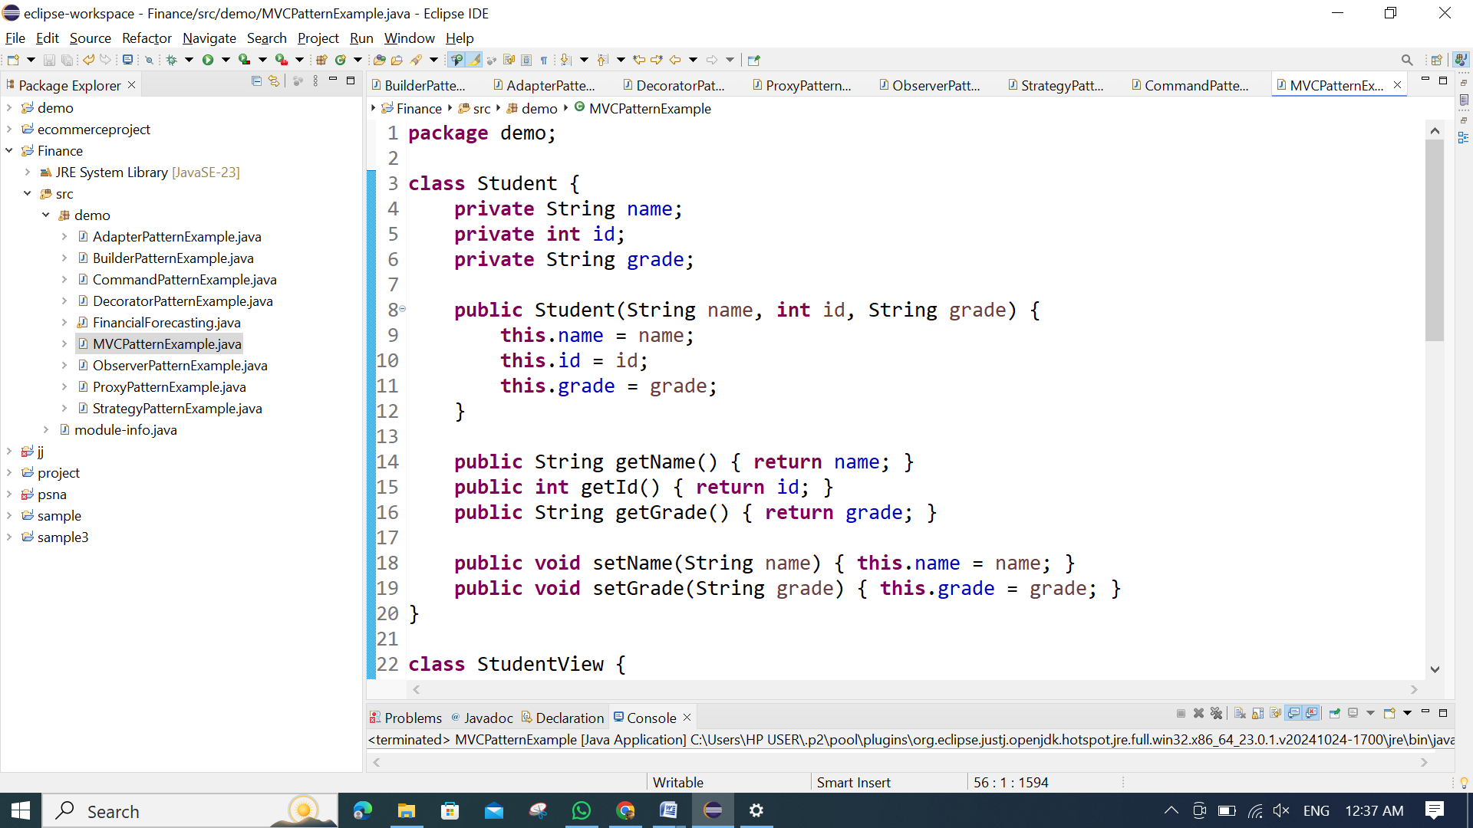

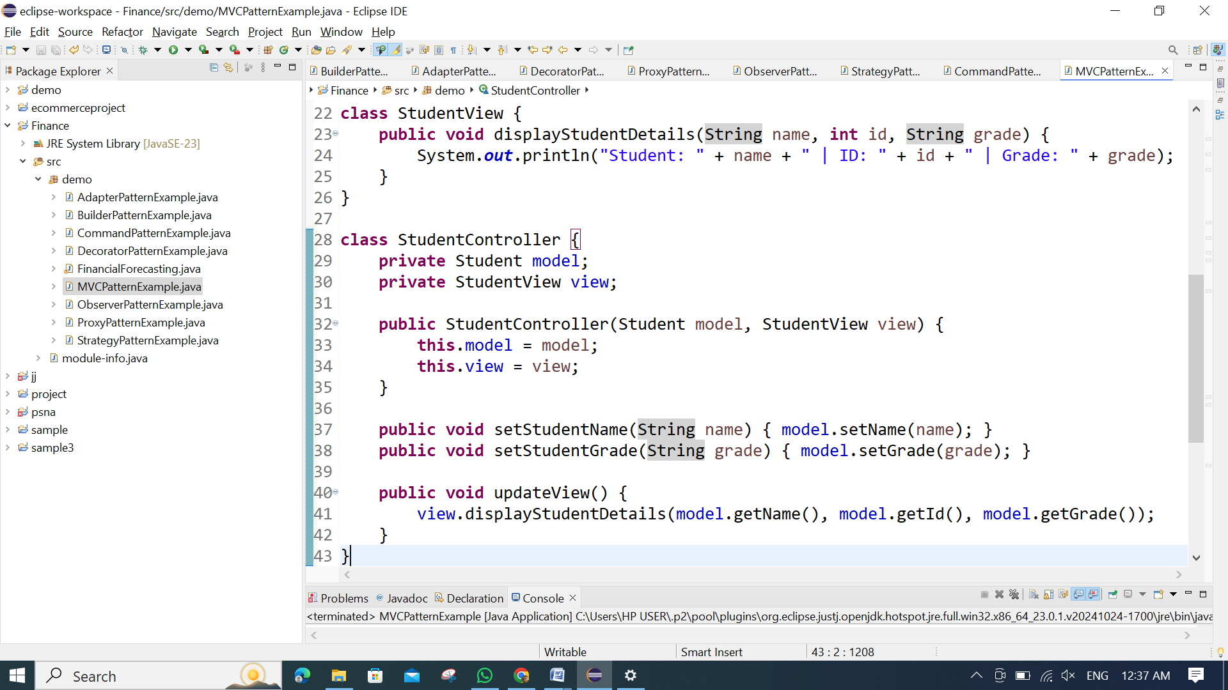

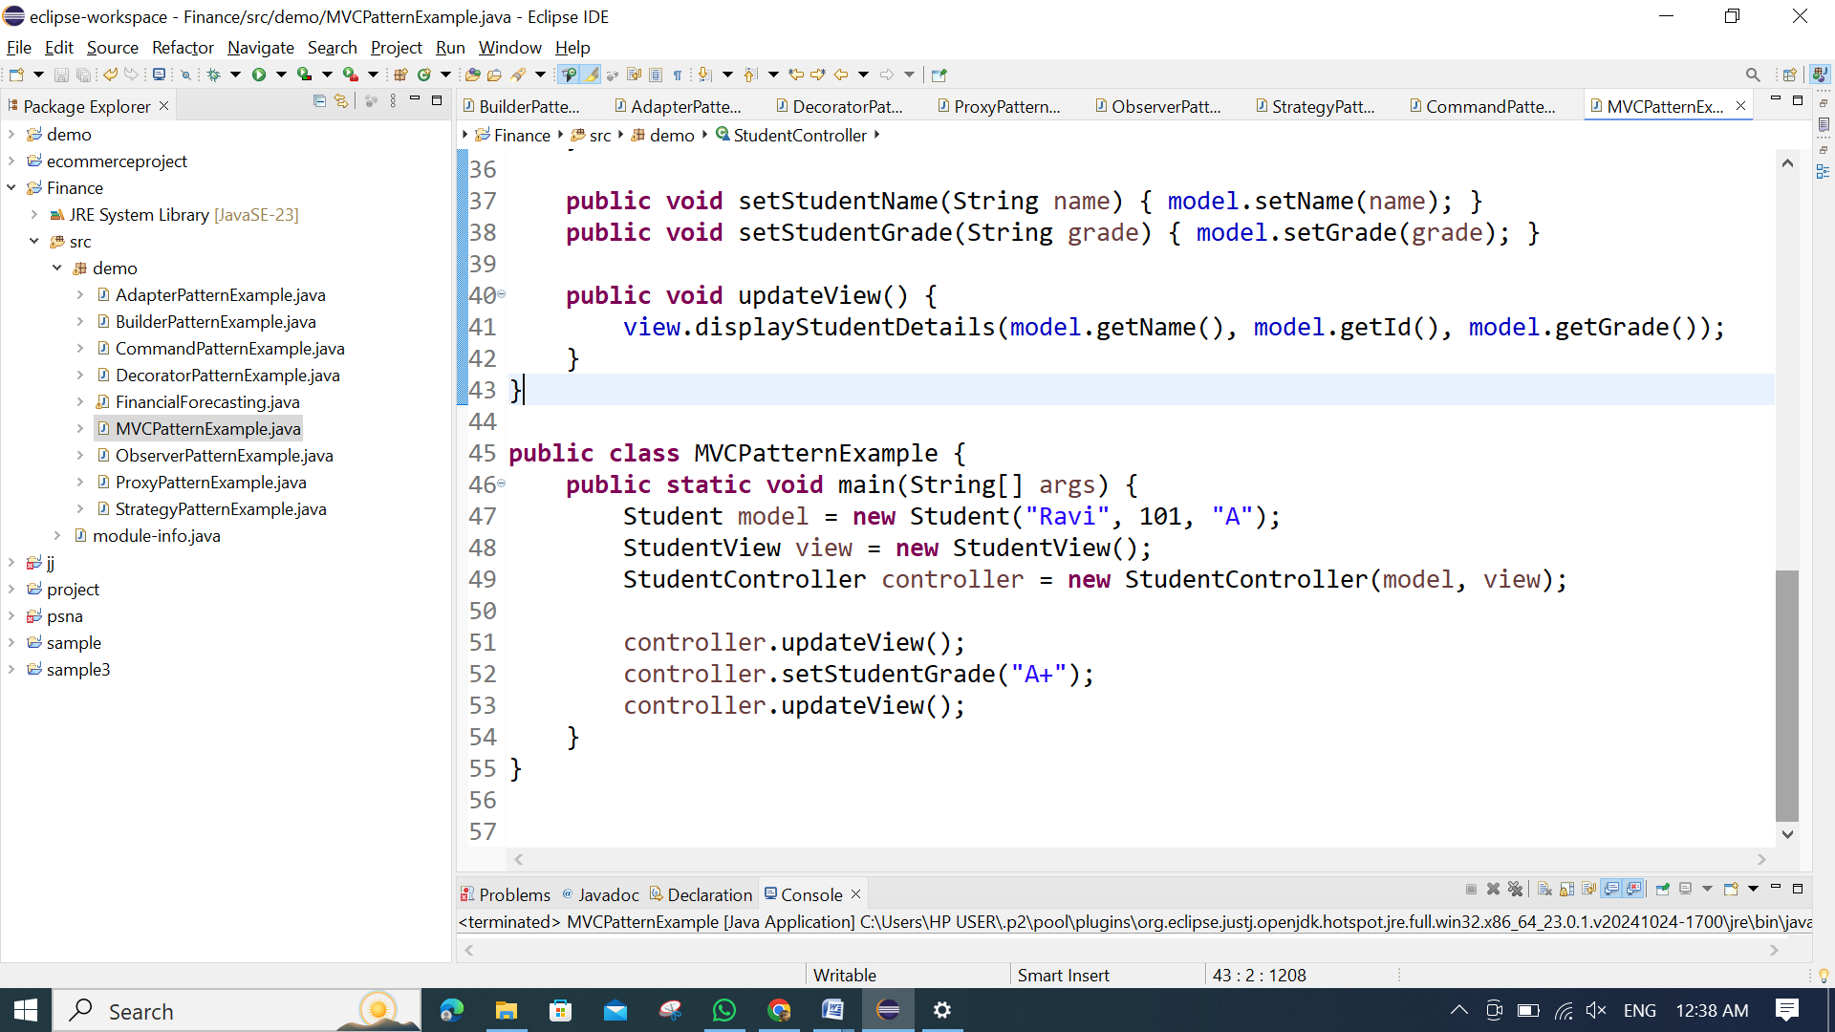

**OUTPUT:**

